CSA06507-Generative AI
Lab Experiment’s
.
Unit 2: Lab Programs for Prompting
1.Design Zero-shot, One-shot, and Few-shot prompts to generate a product description for a Smart Fitness Watch.
AIM
To design Zero-shot, One-shot, and Few-shot prompts to generate a product description for a Smart Fitness Watch.
ALGORITHM
- Start the program.
- Define the product as Smart Fitness Watch.
- Create a Zero-shot prompt without examples.
- Create a One-shot prompt with one example.
- Create a Few-shot prompt with multiple examples.
- Generate product descriptions for all three prompts.
- Display the generated descriptions.
- Compare the outputs.
- Stop the program.
CODE
print("SMART FITNESS WATCH - PROMPTING")
zero_output="""Smart Fitness Watch is a modern wearable device that tracks
steps, heart rate, calories, sleep and workouts."""
one_output="""Smart Fitness Watch offers accurate health tracking,
heart-rate monitoring, sleep tracking and multiple workout modes."""
few_output="""Smart Fitness Watch provides advanced health monitoring,
step tracking, heart-rate measurement, sleep analysis and workout modes."""
print("\nZERO-SHOT OUTPUT:")
print(zero_output)
print("\nONE-SHOT OUTPUT:")
print(one_output)
print("\nFEW-SHOT OUTPUT:")print(few_output)
Input:
Product: Smart Fitness Watch
Output:

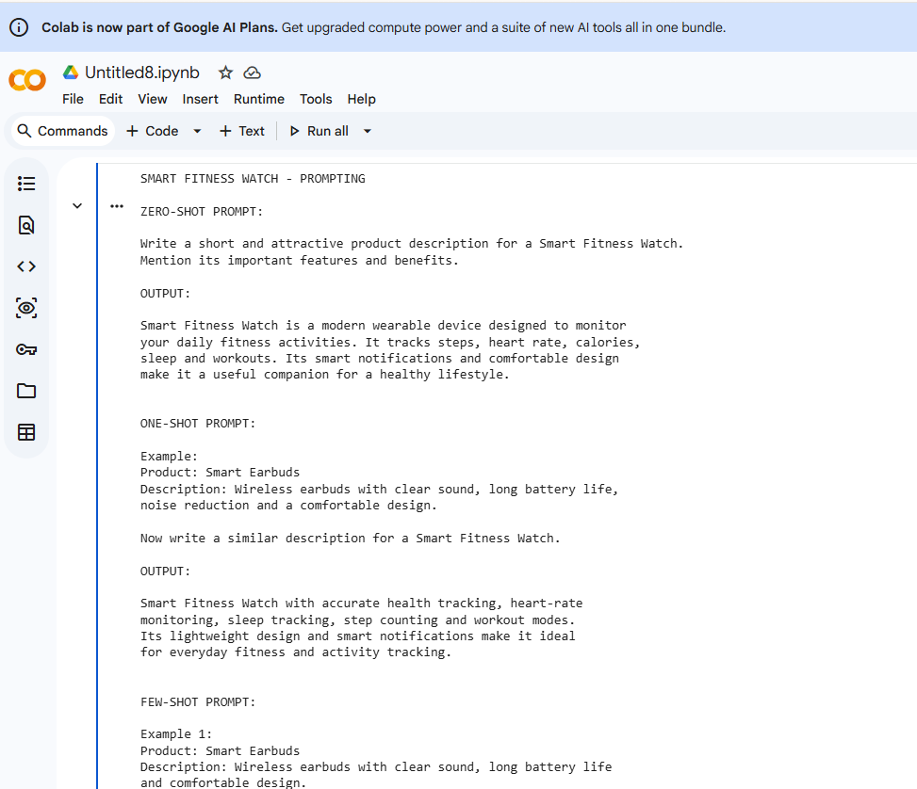
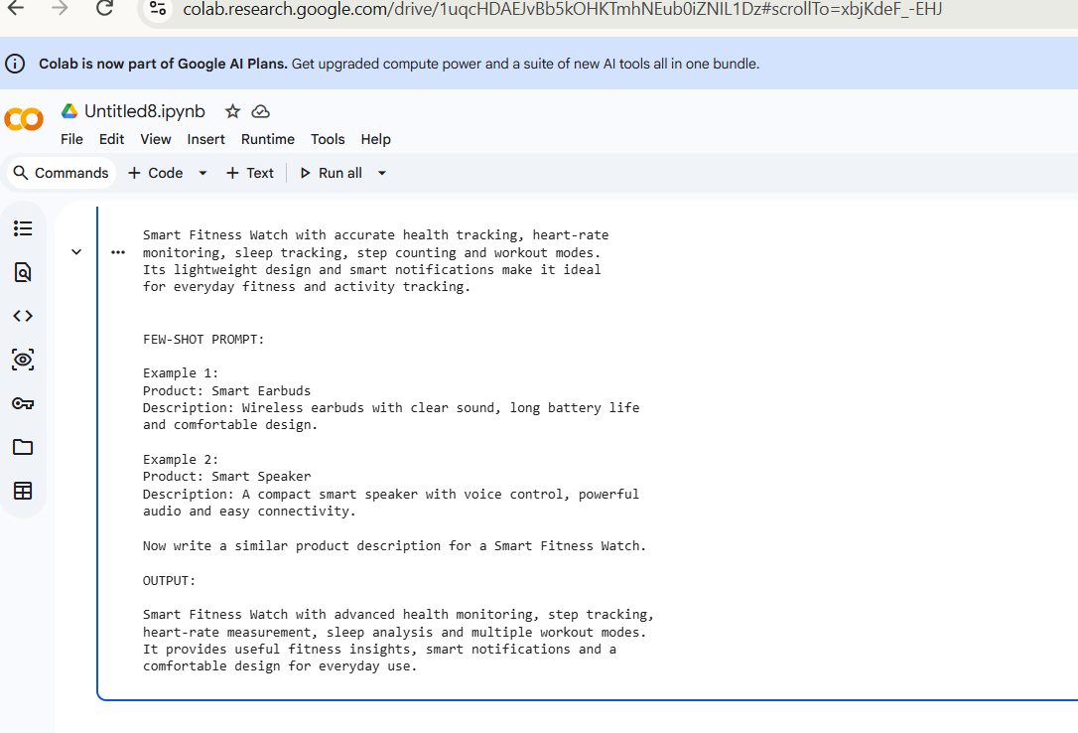
RESULT
Thus, Zero-shot, One-shot, and Few-shot prompts were successfully designed to generate product descriptions for a Smart Fitness Watch.

